1Introduction

1.1 *Purpose*

I propose that Abelardo’s Mexican restaurant in Ames Iowa should replace the pull handle on the East customer entrance. Replacing the handle would provide safe, functional, and convenient entry to the business with the added benefit of improving the appearance of the establishment.

1.2 *Background*

The East customer entrance handle lacks a substantial grab surface, and is a potential safety hazard in the event the plastic/metal surface degrades to a sharp edge. Further, the handle does not have a loop which makes it inaccessible in bad weather, and problematic for someone with a disability. Compared to the West door, the existing handle lacks function and makes the business look run down. The images below clearly illustrate these differences.

(West) 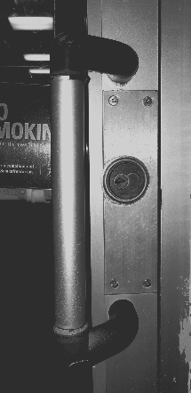 (East) 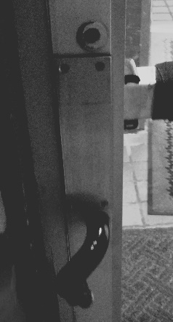

1.3 *Scope*

In this document I will; propose a method to replace the door handle, discuss how this action will benefit the business, and outline the resources and costs required by my method. I will work on the assumption that only the handle needs to be replaced, and a measured replacement of similar style would satisfy the requirements for any city codes.

*2.* Discussion

2.1 *Approach*

I believe the existing fixture is irreparable and must be replaced with a similar concealed surface mount handle. This will be a cost effective means to improve the use of the door while providing the additional benefit of a more attractive fixture. I wish to refurbish the functional East door without removing the handle from the West door, as this would maximize the usefulness of the existing entrances.

2.2 *Result*

My plan will result in a quick, attractive, and cost effective improvement to the use of the door. Replacing the handle may also increase customer satisfaction with the business as a handle is often a component of the customer’s first impression. Overall, this solution provides a significantly lower cost compared to replacing the entire door and frame. In a previous conversation with a representative of the business, I learned a quote for replacing the door was over seven thousand dollars. Conversely, my solution requires no downtime for the restaurant with a fair cost for materials and labor.

2.3 *Statement of work*

* Step 1: Remove broken fixture, measure surface for handle dimensions and required mounting hardware.
* Step 2: Find a replacement which satisfies the size, configuration, and aesthetic required by the business. (See example product from the CRL-US web catalogue below)
* 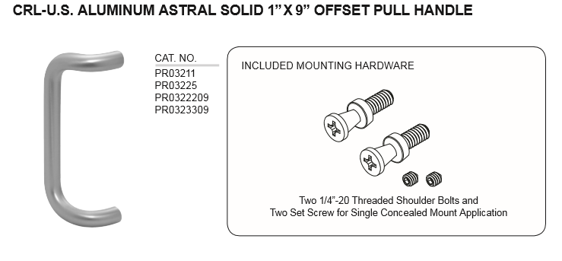Step 3: Install the replacement as per manufacture instructions.

3. Resources

3.1 *Personnel*

I feel confident that I am qualified to perform this work for Abelardo’s Mexican restaurant. I have experience in technical and practical maintenance settings. I have also done similar tasks on my family’s property. I am a detail oriented person who takes pride in the quality and timeliness of my work.

3.2 *Facilities/equipment*

Required hardware and equipment:

|  |  |
| --- | --- |
| Hardware: | Tools: |
| New Handle | 24V Cordless Drill |
| Through bolts | Screwdrivers (Philips, Flathead) |
| Lock screw | Reverse extractor bits |
| Washers | Measuring implements (tape, micrometer, thread gauge) |
|  | Finishing / cleaning supplies |

*4.* Costs

4.1 *Fiscal*

|  |  |
| --- | --- |
| Item: | Cost in dollars: |
| New handle, and hardware | ~ $100 |
| Labor at $10/hr. | $50 |
| Supplies and tools | $0 (Included in labor) |
| **Total** | **$150** |

The price of a sturdy concealed mount pull handle in online stores appears to range from $20 to upwards of $200. I estimate that this application does not require a luxury model and could be satisfied by something locally sourced for about $100. I charge $10 for hourly work. But, I am willing to negotiate on the basis of business credit as well.

4.2 *Time:*

|  |  |
| --- | --- |
| Item: | Time required (Hours): |
| Removal and Measure of handle | 1 |
| Owner Selection and Purchase of new part | 2 |
| Prep and installation | 2 |
| **Total** | **5** |

I predict the total time required for this retrofit to be less than five hours. This estimate accounts for the time needed to carefully remove the old handle, take accurate measurements for a replacement, and allow the owners to select from available options. I feel it is not an overly generous estimate because it accounts for any unforeseen obstacles I may encounter during the process.

*5.* Conclusion

5.1 *Summary*

The proposed repair of the East customer entrance door handle will provide a safe and attractive replacement for the existing fixture. The total costs of this project are expected to remain under $150, and could be completed in one business day. As a result of my work, Abelardo’s would net an entrance which meets commercial standards with the added benefit of improving the image of the business.

5.2 *Contact*

For further information or for questions please contact the author Robert Thomas at rmthomas@iastate.edu, or Call 515-451-2438 Monday – Friday 8am-6pm.